**DIGITAL MARKETING**

**ASSIGNMENT-1**

**Create a blog or website using Blogspot and Wordpress. Customize the theme design and post new article with 500 words.**

|  |  |
| --- | --- |
| **NAME** | Chelsea Shalin S |
| **REG NO** | 962220106026 |
| **NM ID** | 71E62711DDC457F9CE342FE94C5C6052 |
| **TEAM ID** | NM2023TMID08872 |

BLOGSPOT:

<https://disneyworldzent.blogspot.com/2023/08/disney-world-entertainment.html>

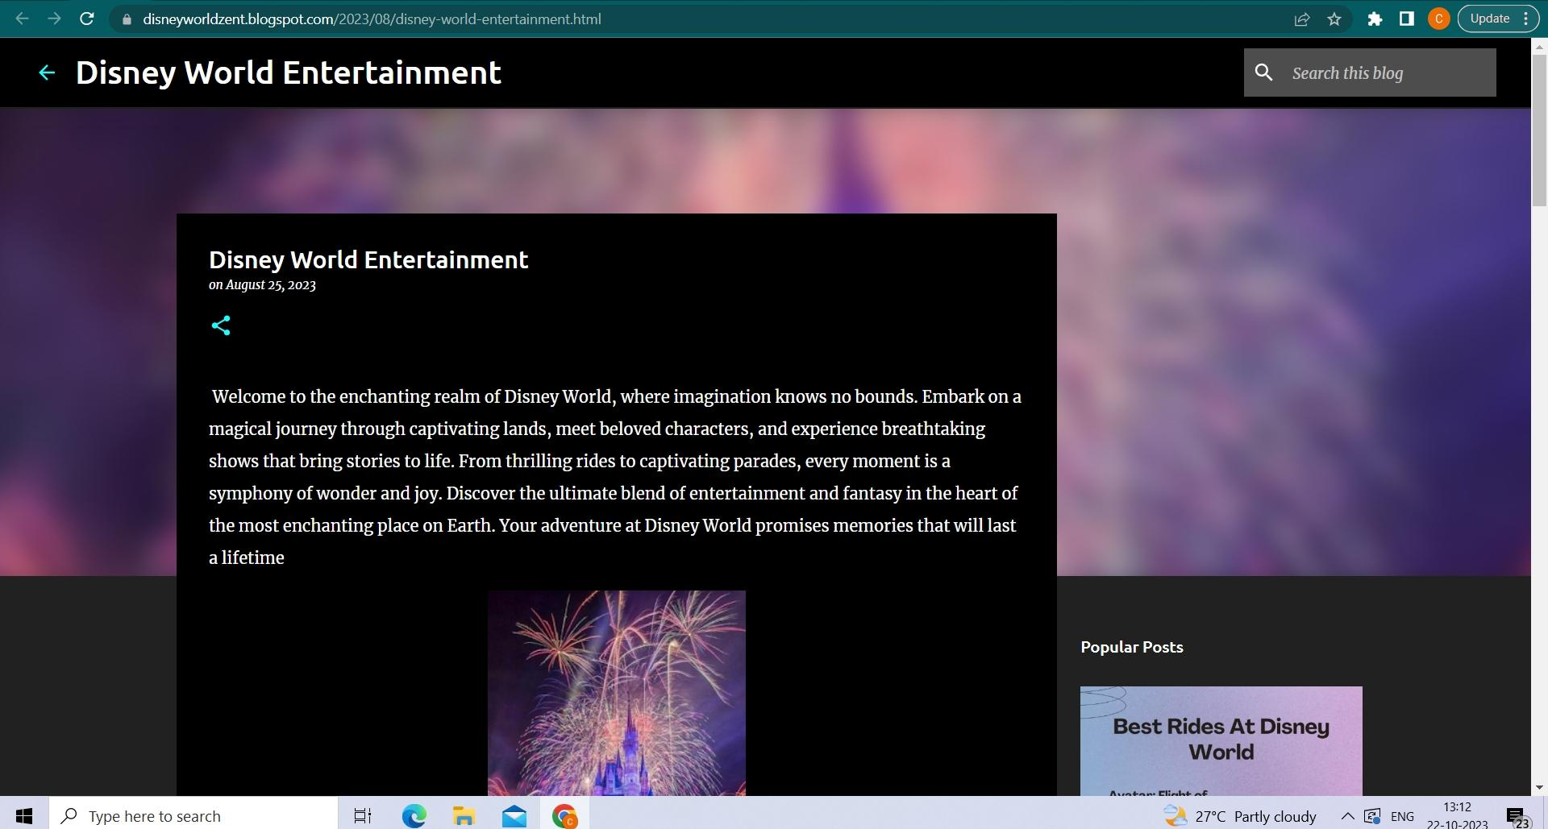

WORDPRESS:

<https://chelzzentertainment9.wordpress.com/2023/10/22/disney-world-entertainment/>

